INFORMACIÓN BÁSICA
NOMBRE DE LA PRÁCTICA:  Laboratorio de texturas | PRÁCTICA No.:  6
ASIGNATURA:
Digital image processing
TEMA DE LA PRÁCTICA:
Texture fundamentals

LABORATORIO A UTILIZAR:

Laboratorio de informática
CONTENIDO DE LA GUÍA

OBJETIVES.

- To perform texture analysis with haralick texture measures.
- To compare the directional frequency texture analysis vs the spatial domain texture analysis.
INTRODUCTION.

Major goals of texture research in computer vision are to understand, model and process texture, and ultimately to simulate human visual learning process using computer technologies.
A typical computer vision system can be divided into components as see in the flow diagram 1Texture analysis might be applied to various stages of the process. At the preprocessing stage, images could be segmented into contiguous regions based on texture properties of each region; At the feature extraction and the classification stages, texture features could provide cues for classifying patterns or identifying objects.
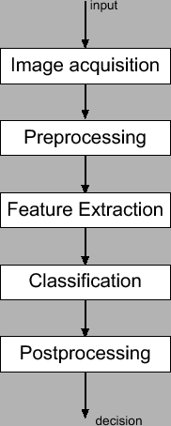
Flow diagram 1.

THEORETICAL FRAMEWORK

Texture is another feature that can help to segment images in to regions of interest and to classify those regions. In some images, it can be the defining characteristic of regions and critical in obtaining a correct analysis.

In the image definition the minimum and basic unit to understand images is the pixel in texture the minimum
basic unit is called Texton or Texel. Texture gives us information about the relationship between color, intensity, distribution, orientation and perception. The information provided by a histogram is not always the best ay to way to understand an image, for example in the following figure all the images have 50% of probability of black white and 50% of black values.
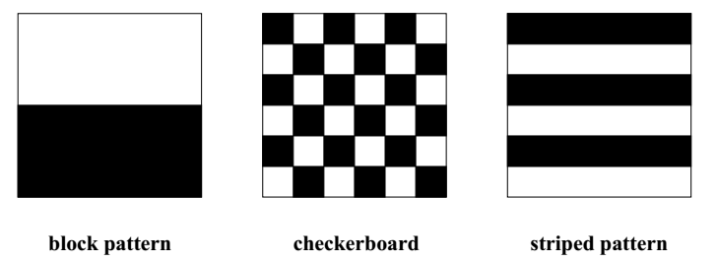

Texture is a common form of understanding of our world and its present in every natural image, sand, stones grass
grass etc. but similar objects cannot be described by the same texture. Thus texture must be described by
more than the objects present in the scene.
Part of the problem in texture analysis is defining exactly what texture is. There are different approaches:

- Structural: Texture is defined as a set of primitive texels with a regular or repeated relationship. Techniques based
- Local binary patterns.
- Geometry based descriptions.
- Directional Based descriptions.
- Phase portrait maps.
- Statistical: Is the quantitative measure of the arrangement of intensities in a boundary. Techniques based on this approach used as descriptor are:
- Edge Density and Direction.
- Haralick texture features (Concurrence texture feature).
- Law’s Energy measures.
- Autocorrelation and power spectrum

In general from the two approaches the statistical one has more popularity because its computational efficiency.

To extend the knowledge about texture you can see the link http://courses.cs.washington.edu/courses/cse576/book/ch7.pdf
METHODOLOGY

In image processing the use of a wide collection of interest images is called a data set; this kind of information has different inner classification. In texture description it’s necessary to establish differences between images based on a prior knowledge (ground truth). The problem is how to describe such differences in a testing subset of image data. . An example would be assigning a given email into "spam" or "non-spam" classes or assigning a diagnosis to a given patient as described by observed characteristics of the patient (gender, blood pressure, presence or absence of certain symptoms, etc.).

Running the descriptor for all images in matlab
The following example code, use the collection of images contained in a folder and applies histogram equalization.
clc
close all
clear all
clc
pad=('D:\dataset_distorsion\normal') %direction of the folder that contains the images.
cd(pad) % set the actual path.
imagenes=dir(fullfile(pad,'*.png')); % search all files with the .png extensión.

for i=1:1:length(imagenes) %use each IMAGE OF THE COLLECTION.

nombre=imagenes(i).name;
I=imread(nombre);
Iout=histeq(I);
Imshow(Iout,[])
end

PREVIOUS KNOWLEDGE
- Read about texture feature extraction.
- Read about the concept of confusion matrix.
- Read about distance measurements.
MATERIALS AND EQUIPMENT

Materiales y Equipos | Reactivos | Materiales Estudiante
Matlab (image processing toolbox)

PRECAUTIONS AND MATERIAL MANAGEMENT.

- Please take care of the computer assigned to you.
- Please do not enter food an liquids.
- Please do not enter your bagpack.

Exercises
Split the Data set in two. The First one a test set with 10 images taking from the each category from the texture data set with no category associated. The Second one without the previously chosen ones categorized.

- Based on the code showed in the above section use a haralick texture description for each of the proposed categories in the data set of textures and save the total of descriptions in a single variable that describes the category used. Apply the descriptor for each image of the test set.
- Implement a function that use the information of the descriptors and compare between two sets (distance measure). Show the results for each category vs the test set in a bar graph.
- Analyse the results and write a conclusion and explain it to your teacher.

BIBLIOGRAFÍA RECOMENDADA.

[1] Digital Image Processing,
Gonzales, R.C., Woods, R.E
2ed, Prentice Hall, 2002

[2] CS425 Lab: Frequency Domain Processing

consultada 17/09/2016.

ELABORÓ  (Personas que elaboraron la guía) | REVISÓ  (Director de Programa o Área) | APROBÓ  (Laboratorios)
Firma Jorge Andres Alvarez Triana  Nombre :  Fecha:8/09/2016 | Firma  Nombre : Diana Paola Ovies Bernal  Fecha: | Firma  Nombre :  Fecha:

INFORME DE LABORATORIO
(Para elaborar por el Estudiante)
ESTUDIANTES: | GRUPO:
ESTUDIANTES: | NOTA:

CARRERA:

Formule tres objetivos que desee cumplir con la Práctica de Laboratorio
El estudiante formulará desde su conocimiento los objetivos para la realización de la práctica

Elabore un Mapa conceptual del tema a tratar en la Práctica de Laboratorio.

RESULTADOS
Incluir tablas, diagramas en la que los estudiantes puedan ir consignando los datos y observaciones obtenidos en la práctica

QUESTIONARY

- Justify the algorithm of haralick.
- How to define a texture.
- What happened to texture if a gaussian, salt and pepper and speckle noise is added?.

CAUSAS DE ERROR Y ACCIONES PARA OBTENER MEJORES RESULTADOS:

El estudiante formulara las posibles causas de error comparando sus resultados experimentales con los teóricos

CONCLUSIONES

El estudiante realizara una serie enunciados que respondan a los objetivos que el mismo formuló, basados en el desarrollo de la práctica.

APLICACIÓN PROFESIONAL DE LA PRÁCTICA REALIZADA

BIBLIOGRAFIA UTILIZADA
[1] Digital Image Processing,
Gonzales, R.C., Woods, R.E
2ed, Prentice Hall, 2002

